PokeFandom

Project Deliverable 2.1

Low Fidelity Mock-Up

SEG 3125

Prof. Caroline Barrière

# Website Overview

## Title

**Poke**Fandom

## Description

**Poke**Fandom is a website for fans of the internationally acclaimed videogame franchise, Pokemon. This website offers a way to navigate the catalogue of Pokemon to learn their stats, consume articles of various Pokemon lore or fan-theories, and a way for the user to guess Pokemon based on their silhouette – just like in the cartoons.

## Website Inspiration

Inspiration for displaying Pokemon cards and their stats:

* [Pokemon.com](https://www.pokemon.com/us/pokedex/)
* <https://pokemon-neu-cards.netlify.app>
* <https://play.pokemonshowdown.com>
* [Information that is available via a free API](https://pokeapi.co/docs/v2#pokemon-section)

Displaying Articles

* <https://bulbapedia.bulbagarden.net/wiki/Pokémon_world>
* <https://www.ign.com/pc>
* <https://www.cbc.ca>

Interactive Trivia Game

* <https://pokemoncries.com/select-answers/1>

## **Navigation**

Each page can be reached using the sticky header shown below. This navigation bar is shown on each page so that a user can navigate to any page from any point of their user story.



The home page is the “About” page which describes the pages of interest for users. (Please note that icons and inner text are placeholders.)

## **Interactive Processes**

### Exploration & Analyze Results

The user is able to explore the catalogue of Pokemon and analyze a Pokemon’s statistics upon selection. A [free API](https://pokeapi.co/) will be able to dynamically fetch information for the entire Pokemon catalogue.

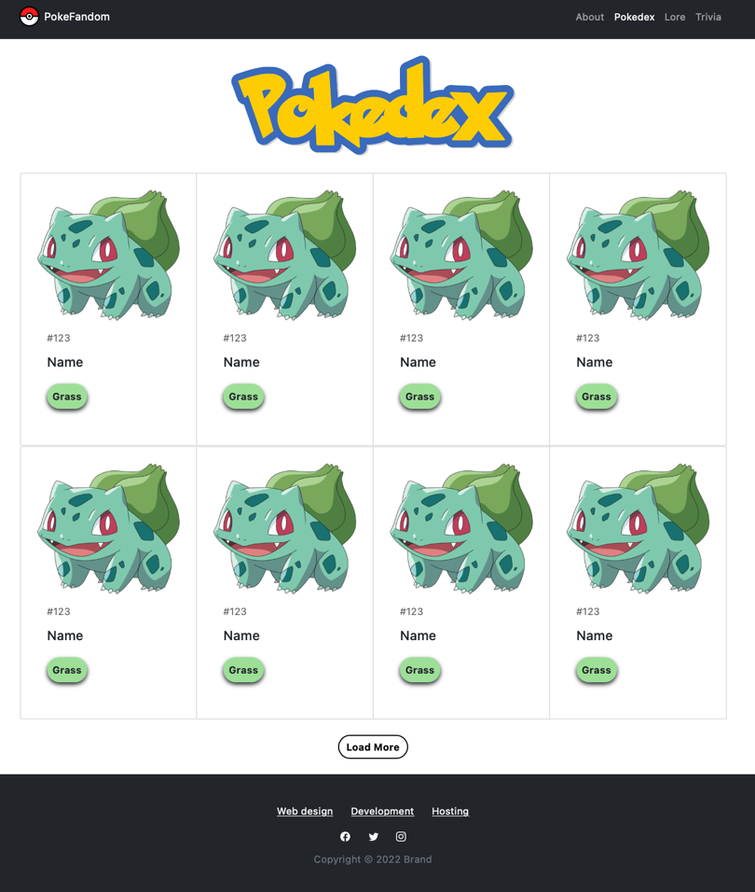

Selecting a Pokemon card will show their detailed statistics.

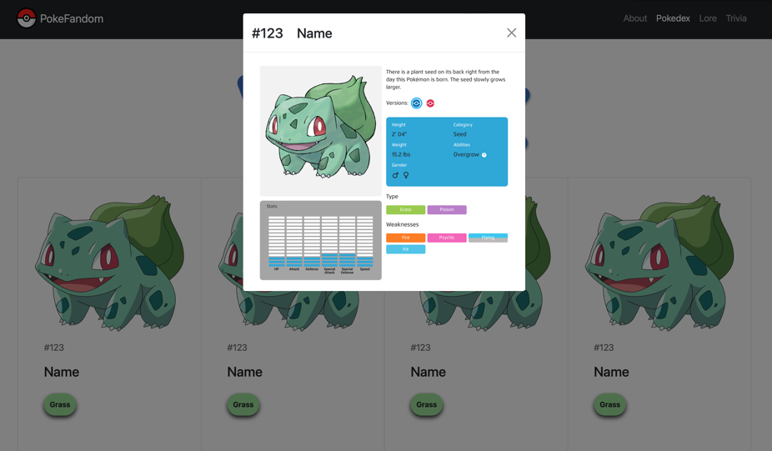

### Absorb Information

A user can absorb information from reading a collection of articles about Pokemon lore or fan-theories. Clicking an article card will show the user the full article to consume.

### Perform a Monitored Activity

Users that watch the Pokemon cartoon are familiar with the “Who’s That Pokemon?!” cut-scene between commercials, as shown below.

This experience is replicated below, where the user is able to perform a monitored activity by guessing the Pokemon silhouette. The user will receive response validation based on their correct or incorrect input.

## Semantic Network

Please see separate attached document for the semantic network.